**Assignment**

• Please look for 5 open-source repositories with the highest number of contributors, stars and commits!

1. freeCodeCamp (<https://github.com/freeCodeCamp/freeCodeCamp>)

freeCodeCamp is the most starred repository on GitHub. It is the backend for the main freeCodeCamp website that offers numerous free computer science learning materials.

1. free-programming-books (<https://github.com/EbookFoundation/free-programming-books>)

Run by the Free Ebook Foundation, this popular repository has become one of the top GitHub projects. It provides a comprehensive list of free learning resources in numerous languages.

1. Public-apis (<https://github.com/public-apis/public-apis>)

This popular GitHub repository contains a list of free Application Programming Interfaces (APIs) developers can use in web and software development.

1. Developer-roadmap (<https://github.com/kamranahmedse/developer-roadmap>)

The Developer Roadmap repository serves as the backend for Roadmap, an educational site offering free learning materials. It is one of the most popular open-source repositories on GitHub, guiding users through their chosen learning paths to become web developers.

1. Coding-interview-university (<https://github.com/jwasham/coding-interview-university>)

The Coding Interview University repository by jwasham is a computer science study plan for those interested in pursuing a career as a software engineer.

• Create a daily activity using a kanban board for 4 weeks (2 weeks back and 2 weeks ahead), at least the kanban structure consists of To Do, In Progress, and Done!

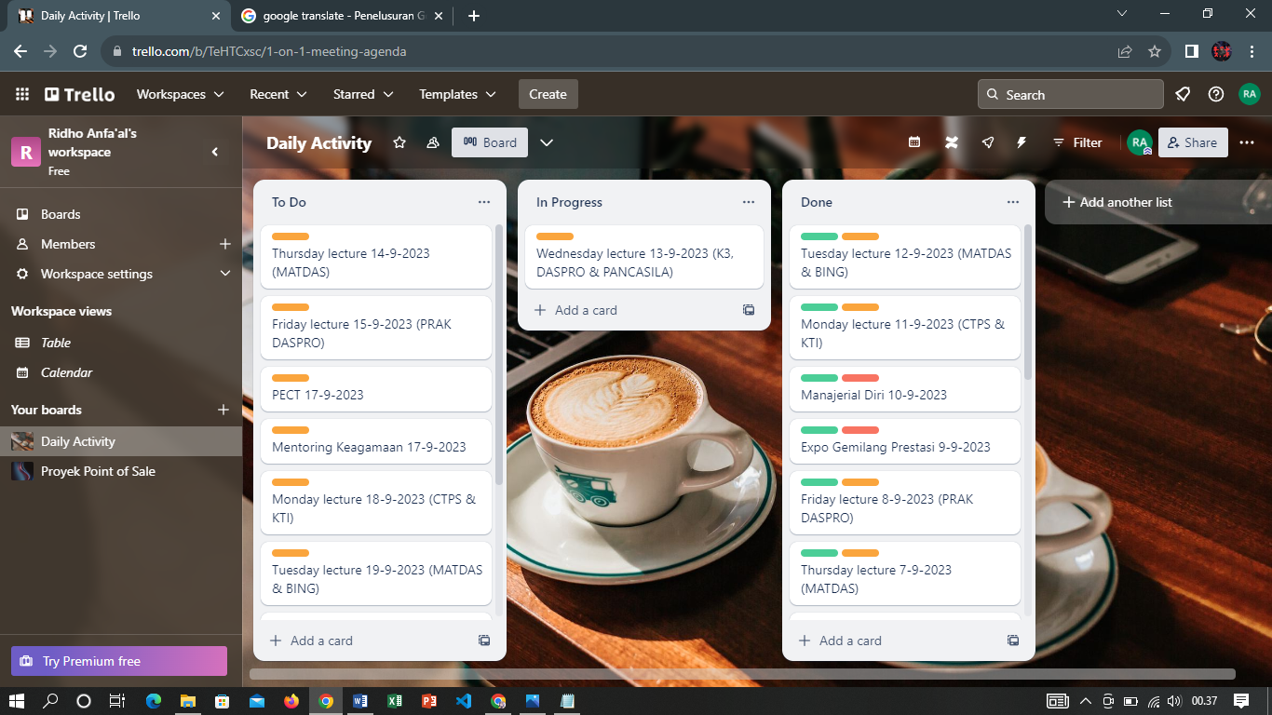

Trello link : <https://trello.com/invite/b/TeHTCxsc/ATTI929c1b298f5a40f057d3f66e328c5cf9B02B73E5/daily-activity>